RampDesign

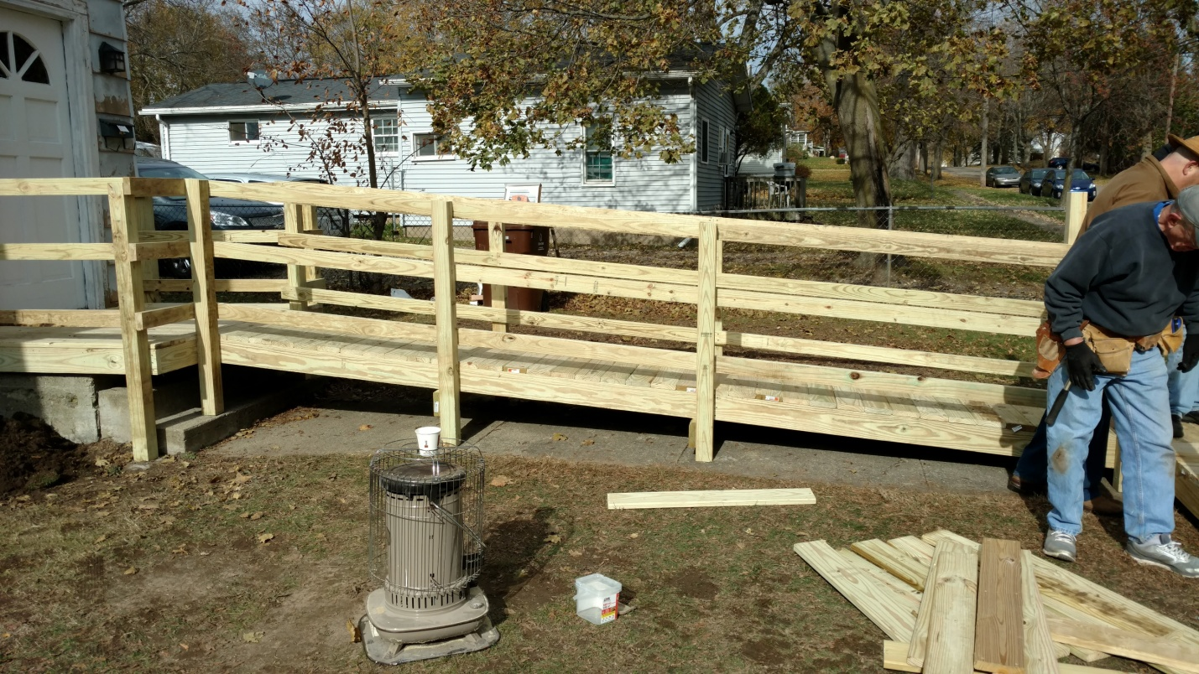

User Guide

and

Installation Documentation

**Table of Contents**

[**Introduction**](https://docs.google.com/document/d/1NHKFcJA-1lAKZ4z8GnaioLsY4KqIHA1GndIYvwacD7k/edit#heading=h.992mksyh0u3l)

**Installation**

**User Guide**

**Usage Information**

**Introduction**

Ramp design in a free to use software created by Western Michigan University's senior design team, for the purpose of aiding in the design process of ramps for Habitat for Humanity, Battle Creek chapter.

**Installation Guide**

This section will go through the steps for installation.

**Basic installation**

1. Download latest version of the program at:

<https://github.com/WMU-CS-HFH-Group/ramp-designer>

**Advanced installation**

1. Download latest version of the program at:

<https://github.com/WMU-CS-HFH-Group/ramp-designer>

2. Open in Eclipse Java IDE

3. Right Click ramp-designer

4. Click Export…

5. Expand Java

6. Choose Runnable JAR file

7. Click next

8. Under Launch configuration: